19.32: a) See also Exercise 19.36;

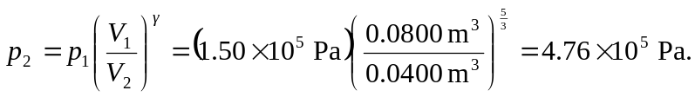

b) This result may be substituted into Eq. (19.26), or, substituting the above form for 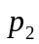,

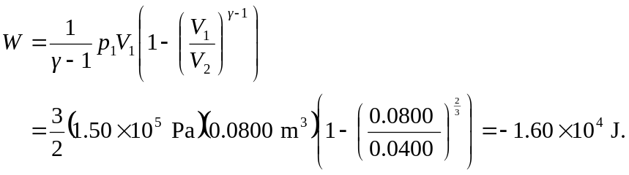

c) From Eq. (19.22), and since the final temperature is higher than the initial temperature, the gas is heated (see the note in Section 19.8 regarding “heating” and “cooling.”)

